The editorial board will show the carousel of top 20 editors in our list

It will show name in big letters and department in small letters. By clicking on it more details will appear like this

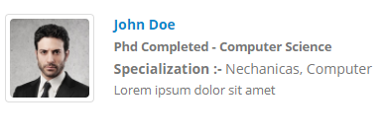 

It should be containing values from DB

1. Image, If not then default image
2. Name In Blue As Showed
3. Qualification - Branch
4. Specialization – Data from Specialization

This should be scrollable

Features: this tab should have color variations : Data of features will be given. Better if can be added from CMS

<http://preview.oklerthemes.com/porto/6.0.0/page-services.html>

Testimonial should be added from CMS

Authors Menu

The how to publish content is not in flow

Also the representation is bit old